

System Maintenance and Technical Document (SMTD)
Application Suite
Version | 1.0

<CLIENT LOGO>

Document Details
Prepared by/Date | Reviewed by/Date | Approved by/Date
Revision History
Version | Date of Revision | Description of Change | Reason for Change | Affected Sections | Approved By
Draft
Affected Groups

1. Scope and Purpose 4
2. Application Overview 4
3. Business Processes 4
4. Application Access Procedure 4
5. Initial Status of the Application under Maintenance 4
5.1. Modules/Interfaces/Data structures 4
5.2. Documents 4
5.3. Standards and Guidelines 4
6. Application Environment 5
7. Affected Systems/Applications 5
8. User Interfaces 5
9. Application Design 5
9.1. Relation to External Systems 5
9.2. System / Sub-system Architecture 5
9.3. Inter-module Relationships 5
9.4. Application Modules 5
9.5. Database Details 6
10. Global Data Structures and Shared Data Functions 6
11. Critical Functions 6
11.1. Testing Strategies 6
11.2. Test Data 6
13. Reusable components 6
13. Limitations 6
14. References 6
15. Application History 7
15.1. Typical Problems 7
15.2. Release History 7
17. Learning 7

Terminology and Acronyms

Terminology/ Acronym | Definition
STARS | Service Tracking and Resolution.
CMAR | Change Management Action Request
KB | Knowledgebase
AMS | Asset Management System
SrvConf | Server Configuration

Scope and Purpose
This document is intended to capture the information of the application as acquired during the training and parallel perform phases. This is an evolving document and will be updated through the training and parallel perform phases. The sections in this document indicate the type of information that would be typically required to carry out the support/development/test activities during the steady state. The scope of this document is to point to the relevant documents available with Texas Instruments that would be used by Wipro to support the steady state activities. In cases where there are no documents pertaining to the information required in the section, the Wipro engineers will include a brief description based on their learning.

Application Overview
STARS (Service Tracking and Resolution System)
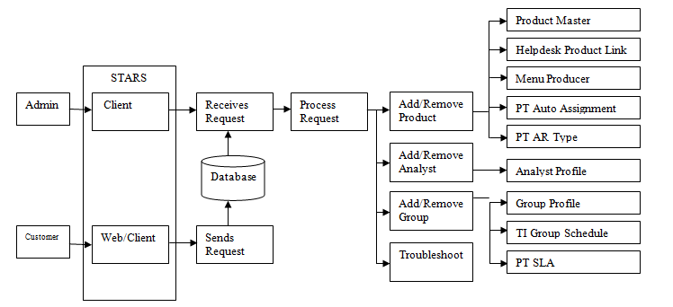
STARS is a ticketing system used by customers and analyst to submit a ticket request that will be solved by an analyst/admin. There are a lot of forms or windows to be used depending on the request of the customer. The request will be stored to the database that will be fetched by the admin and then it will be processed depending on the ticket request. If the user requested to have access to STARS then the analyst/admin will use the Analyst Profile form to give permissions and access. Different ticket request uses different forms as shown below.

AMS (Asset Management System) is an application being used by Texas Instruments as a repository of Asset Records. Using the application, it easier for users to lookup asset information and for asset admins and cost managers to modify this asset information.

SRVCONF/ServerConfig is a Web application for all servers in TI. This application also host informational and contact data used on many other internal sites including Assets, IT Contacts, Groups, and other information regarding servers. This web application simply provides details and records for any specific server.

Server Config is a web based application that contains system and support information used by IT Operations support teams. Parts of the support information are the associated escalation lists that include technical contact lists, production stop (situation manager) contact lists and list owners.

Knowledge Base (KB)
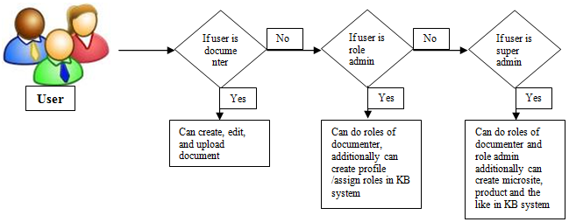
Is an application that serves as a general repository for “Best Known Method” in troubleshooting or for well documented processes being used in TI Worldwide. Inside of it contains a lot of documents that is sorted to “products” with respect to the “microsites”. The application also has capability to set type of “users” that uses the application on their needs.

Business Processes

AMS

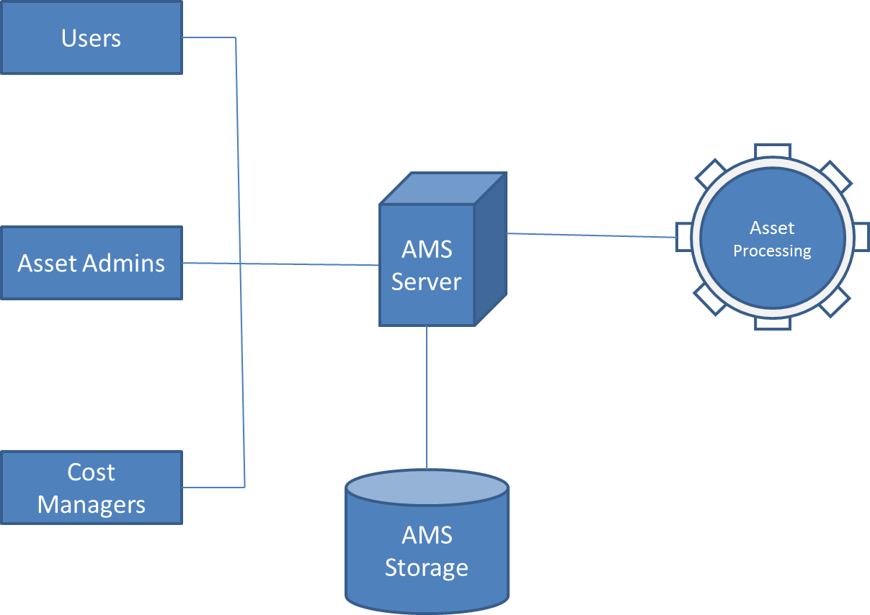

STARS
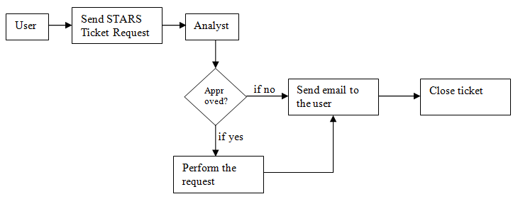
In STARS, not all ticket requests are being approved by the admin support there are still processes that the admin should consider. Users send a ticket request in the STARS then this ticket will automatically assign to the group and it will be assigned to an analyst. The analyst will now evaluate the request because not all requests from the users are approved. If the ticket request is approved then the analyst will perform the request and then send a ticket to the user saying that his/her request is already done, if not the analyst will send an email to the user and will inform his/her that the request is not possible or it is beyond the limit of their support.

SrvConf
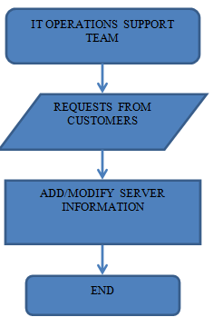

KB

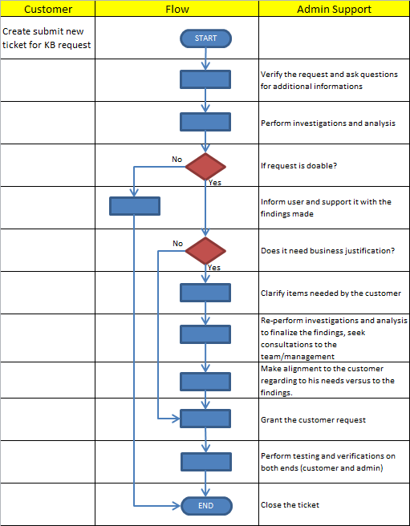
As seen on the above, role admins and super admins are the ones that can modify profiles, items and structure in KB. While documenter profiles are the users that needs to have profile in KB to upload document they want to share.

Customer can request role, new microsite, products and the like in KB. Below image shows the process if that request is doable or not and classified if needed business justification or not. Admins do investigations, bargaining and justifications to the request if that request seems to have an impact to the KB application.

Application Access Procedure

STARS
How to install BMC Remedy Client Tool
- Save the installer (Remedy User Tool 7.1 Patch 006.exe) to your computer.
- Right click on the installer then choose Run as Administrator.
- Click on next then finish.

How to login to the STARS Web
- Type stars to your Internet Explorer (ie) browser.
- Then click on the Login to STARS Control Panel.
- Enter your User ID and Password.
- Click on Login.

How to login to the STARS Client
- After you successfully install the BMC Remedy Client Tool, open it.
- Enter your User Name and Password.
- Click on the Options button beside the Password field.
- Then on the Preference Server type on starbase.
- Click on the OK button.

AMS
In accessing the application follow the steps below:
- Go to Start>All Programs>Action Request System>BMC Remedy User
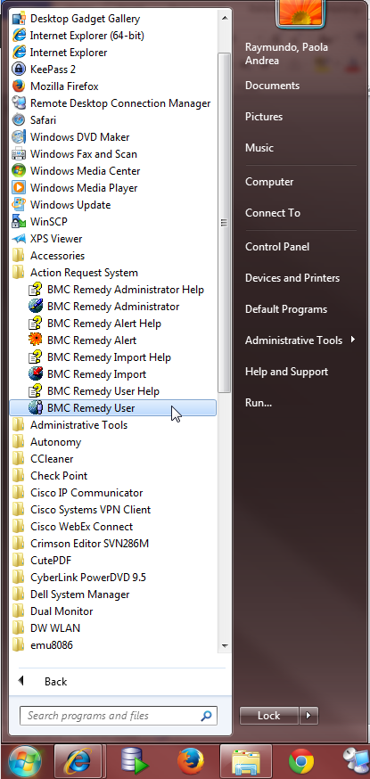

- Press the “Options” button in the prompt and input the “User Name”, “Password” and “Preference Server”
NOTE: Preference Server for Prod=”dlegp”
Preference Server for Dev=”dlegf”
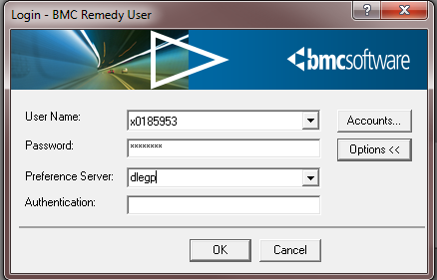

- Click OK

KB
Access in KB can have two different ways, one is Admin Profile which is being used by STARS admin support and another one is KB User which they use kb to create, edit and upload the documents.

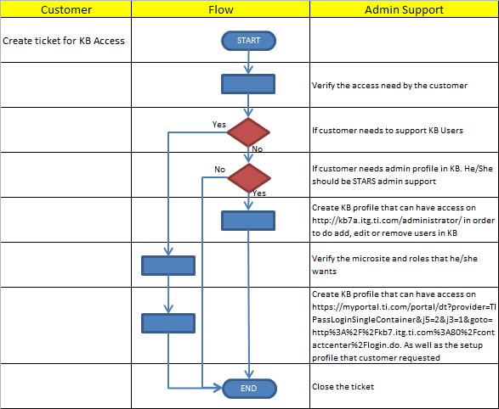

Server Config

Go to or use the URL: serverconfig.itg.ti.com for production and for the development use the URL: srvconfdev.itg.ti.com

Login procedure to access the application use TI-pass Login (see below screenshot). No installation needed because it is a web application.
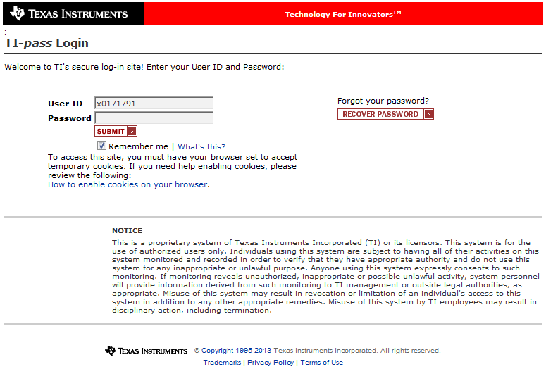
You can request access to the SRVCONF web app by submitting a ticket to STARS:
Site/Helpdesk: IT Services
Product: SW-Customer Support Tools-Server Config

If User has an Admin Profile, he/she can access this link http://kb7a.itg.ti.com/administrator/ that will redirect to this page.

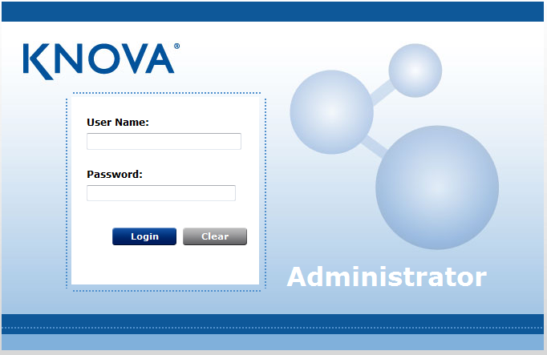

If User has an KB User Profile, he/she can access this link
https://myportal.ti.com/portal/dt?provider=TIPassLoginSingleContainer&j5=2&j3=1&goto=http%3A%2F%2Fkb7.itg.ti.com%3A80%2Fcontactcenter%2Flogin.do that will redirect to this page

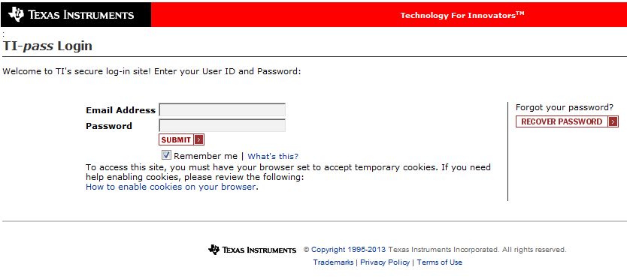

Initial Status of the Application under Maintenance

Modules/Interfaces/Data structures
Not applicable since the document is for Admin Support

Documents

STARS
https://itsps.itg.ti.com/sites/EMAGroup/STARS/Shared%20Documents/Forms/AllItems.aspx

AMS
https://itsps.itg.ti.com/sites/EMAGroup/AMS/Shared%20Documents/Forms/AllItems.aspx

KB
https://itsps.itg.ti.com/sites/EMAGroup/KnowledgeBase/Shared%20Documents/Forms/AllItems.aspx

SrvConf
https://itsps.itg.ti.com/sites/EMAGroup/SRVCONF/Shared%20Documents/Forms/AllItems.aspx

Standards and Guidelines

STARS
Products which are being requested to be created should not exceed 48 characters.
Group Name should have (LHD) on the end.

CMAR
Group Name should have (CM) on the end.

AMS
During asset mass upload, ensure that the list sent by customer is 50 assets or more to proceed

KB
In setting up a product ensure that it is unique
In setting up KB user profile be sure to always update the “Universal Metadata” field

Application Environment

Development Environment |  | Test Environment
STARS  Software used: BMC Remedy Version 7  Server: Dlecq – starbase (production)  Dlejg – starsweb1 (midtier server)*  Dlejh – starsweb2 (midtier server)*  AMS  Software used: BMC Remedy Version 7  Server: dlegf  Database: LEDAMS  Server Config  Site: srvconfdev.itg.ti.com  Application: Dles154  Database: Dlevds05 |  | STARS  Software used: BMC Remedy Version 7  Server: Dledz – starcert (certification)  KB  Server: DLEV 175  DLEV 176
Staging Environment (optional) |  | Production Environment
STARS
Software used: BMC Remedy Version 7
Server: Dleci – stardev (dev)

AMS
Software used: BMC Remedy Version 7
Server: dlegp
Database: LEPAMS

Server Config
Site: serverconfig.itg.ti.com
Application: Dles377
Database: Dlevps05

KB
Server:
Dlev173 - admin server
Dlev174 – webapp contact center B
Dlev337 – webapp contact center C
Dlev338 – webapp self service
Dlev339 – webapp self service

Affected Systems/Applications
.
Affected System / Application | Responsibility  (Wipro/Texas Instruments/Other) | Contact Details
Remedy:  STARS/CMAR  AMS | Texas Instruments | Mark Villamar
KB | Texas Instruments | Mark Villamar
Server Config | Texas Instruments | Mark Villamar

User Interfaces

STARS Web

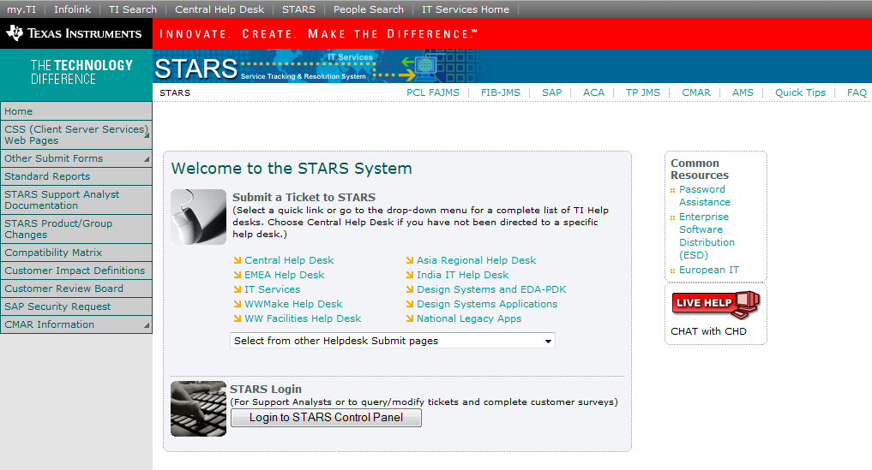
This image shows the main page of the STARS in web. It can be accessed by typing stars into the Internet Explorer browser. Users can create tickets through this page. Users just have to choose what helpdesk they will be creating their tickets. If the helpdesk is not found on the list shown then the users can click on the drop down saying Select from other Helpdesk Submit pages.

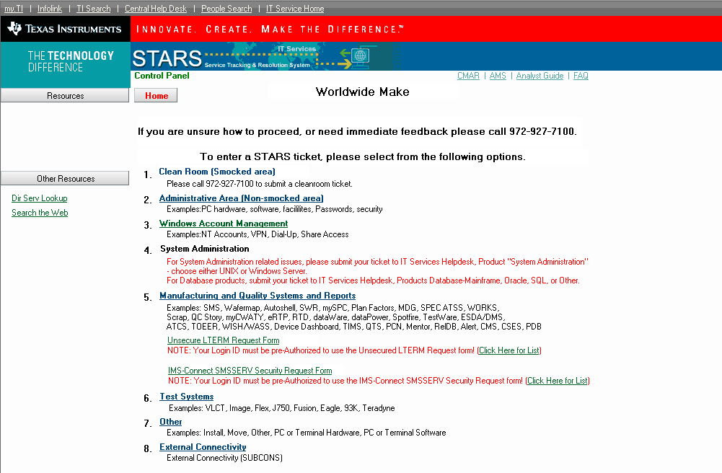

After choosing a help desk, users will be directed to choose a product but other helpdesk doesn’t have this page instead it will be directed to the form immediately.
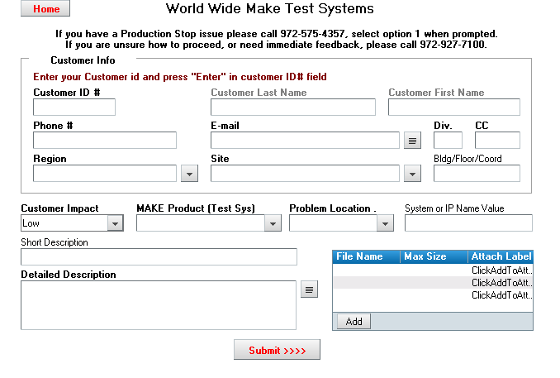
This is a form that a user has to fill out in order to successfully submit a ticket request. A user have to enter his/her ID in the Customer ID # field and press on Enter for it to auto populate the other fields in the Customer Info.

STARS Client

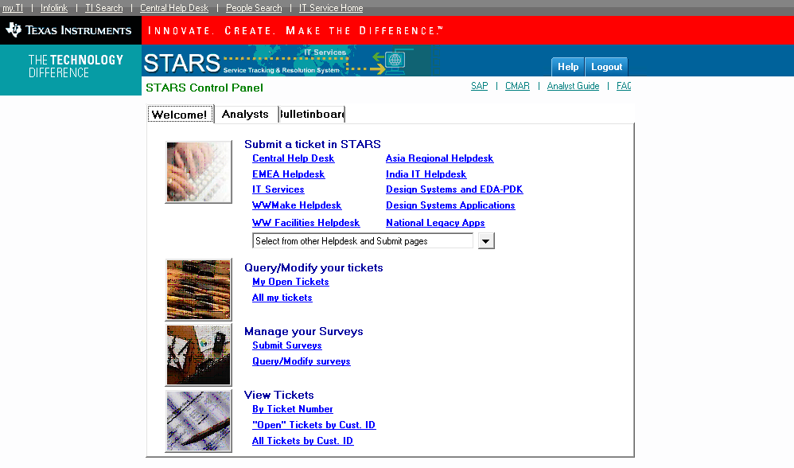
This is the home page or the main page of STARS in the client tool. It is the same as the web but the only difference is that in the web it doesn’t have the Analysts and Bulletin board tab.

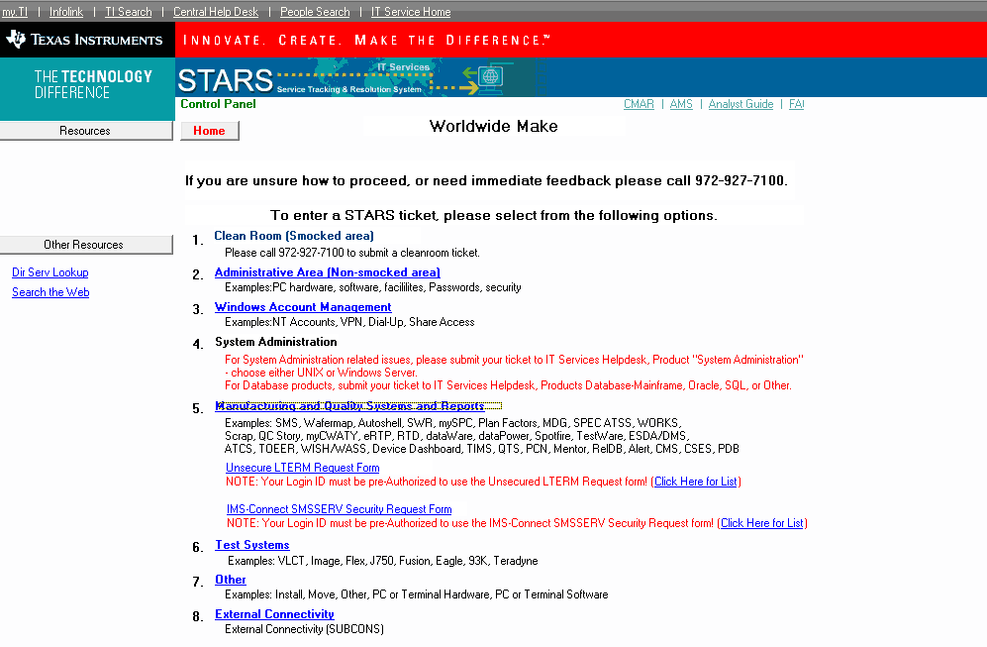
This is also the same as the STARS web.
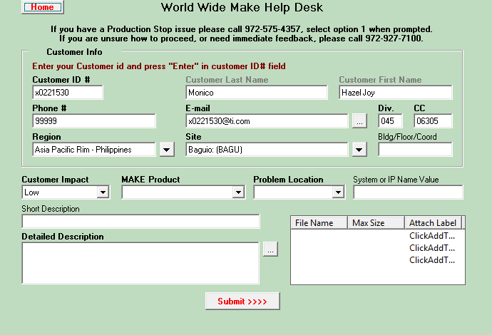
This form works the same as the form in STARS web. User will have to enter his/her ID to the Customer ID # field and press “Enter” to auto populate the other fields in the Customer Info.

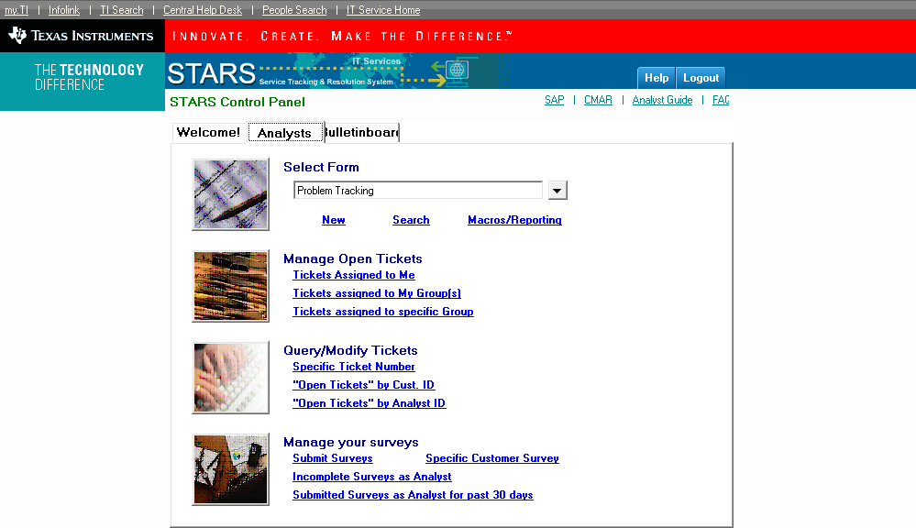
In the STARS client tool, it has an Analyst tab if the user has an analyst profile in STARS but if it doesn’t have then the user will not have the Analyst tab. The Analyst tab enables the user to create a new ticket, search for a ticket, search for other forms available on the drop down list under the Select Form, etc seen on the image above.

Create a Ticket
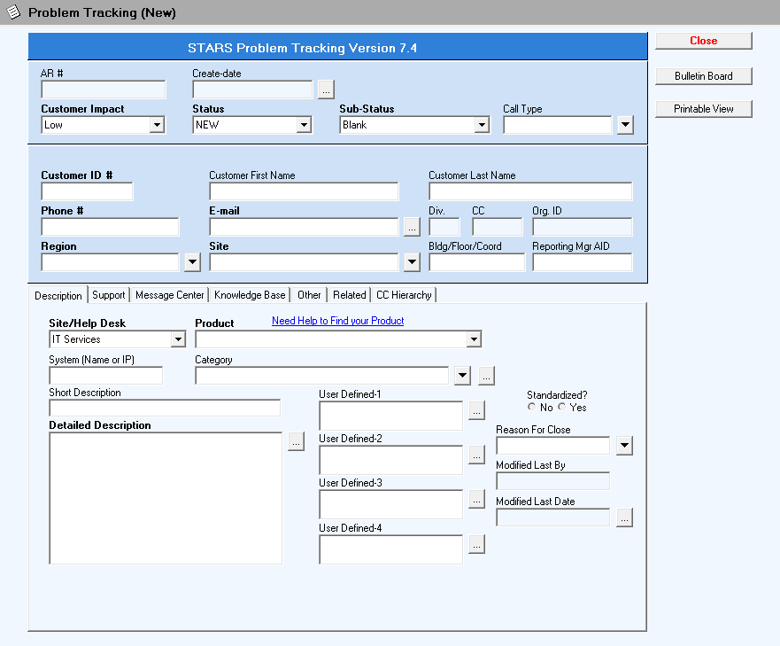
Click on New to create a new ticket request. After that, the Problem Tracking (New) form will be shown. This form is only for the analyst. This form is different from the form that the users use in creating a new ticket. This has more fields or it is more detailed and also typing the ID in the Customer ID # field and pressing Enter will auto populate the other fields in the customer information.

Search a Ticket
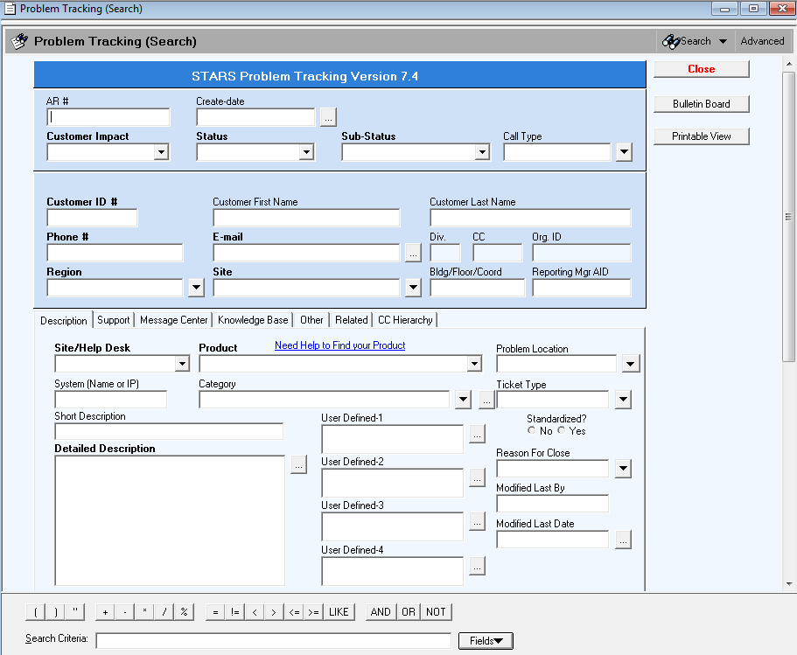
Analysts can search for an existing tickets or closed ticket by clicking on Search. This Problem Tracking (Search) form enables you to search in different ways. This is by using the Advanced search. The Advanced search button is located on the top right portion of the form. If the Search Criteria field at the bottom is not shown then just click on the Advanced button.

View the Ticket Assigned To Me

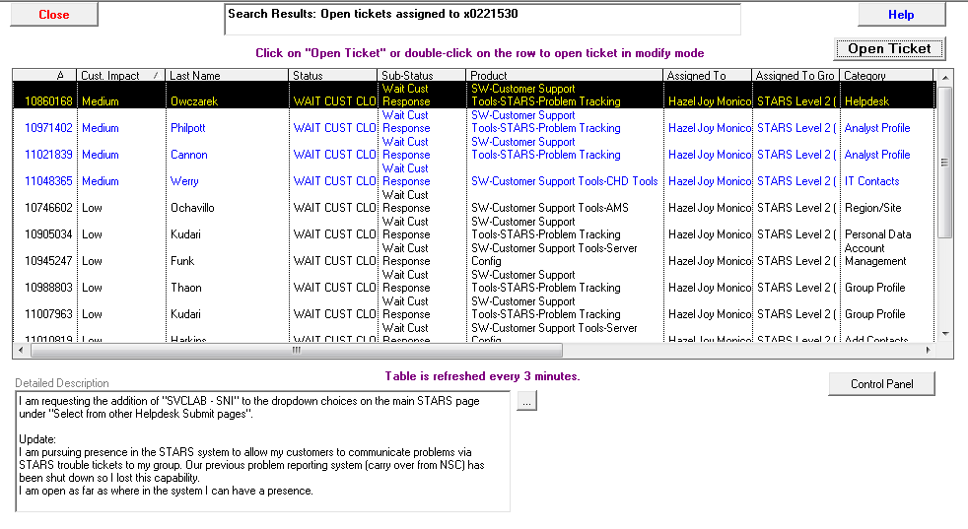

View Ticket Assigned To My Groups

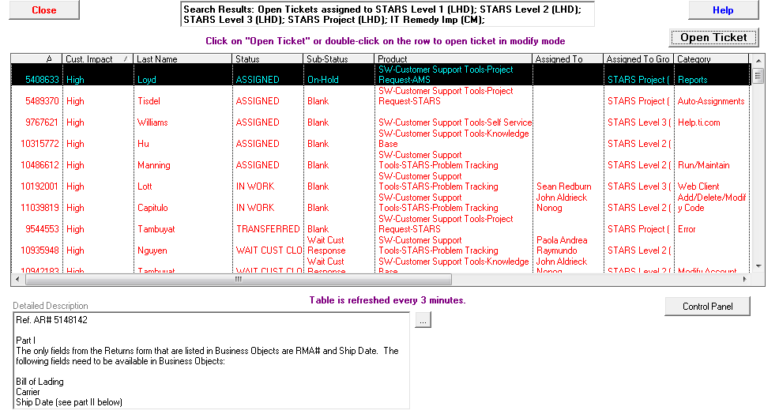
Ticket Assigned To specific Group
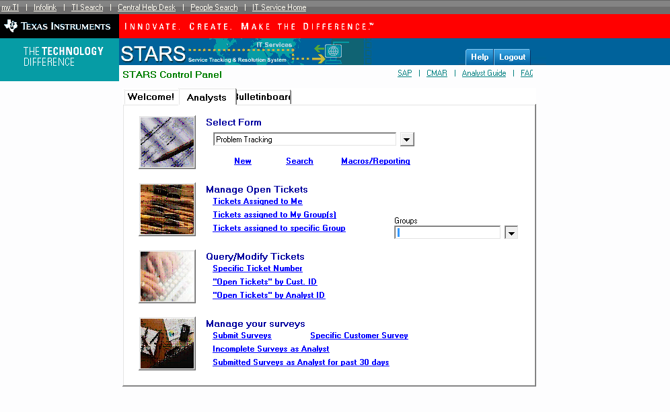

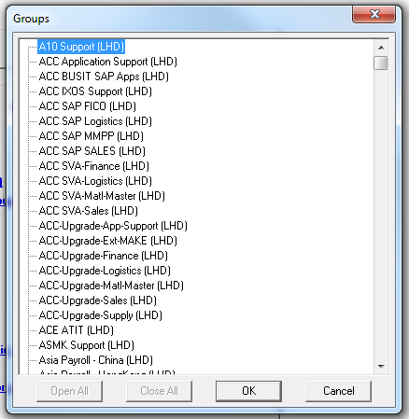
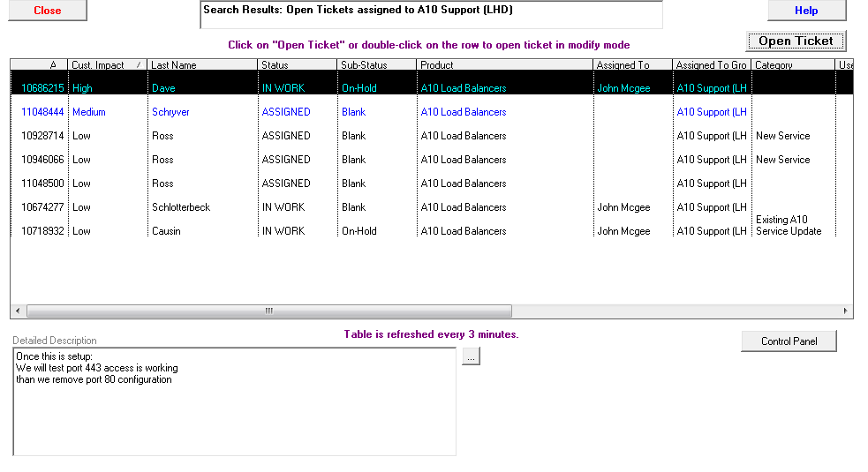

Search for a Specific Ticket Number

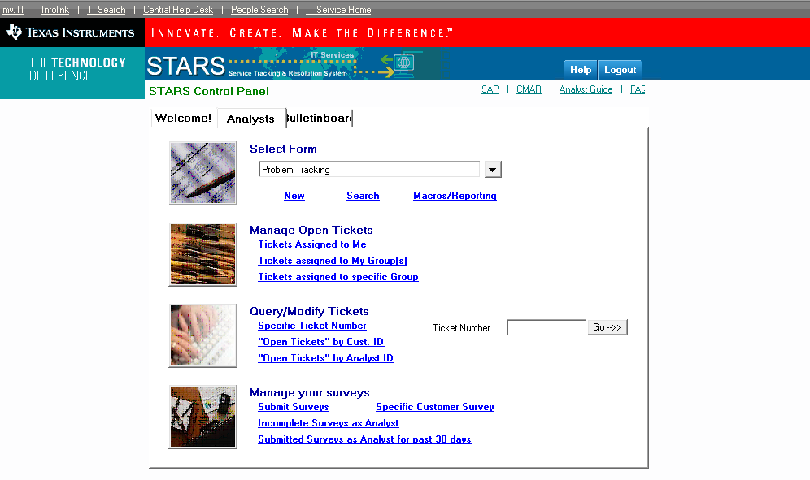

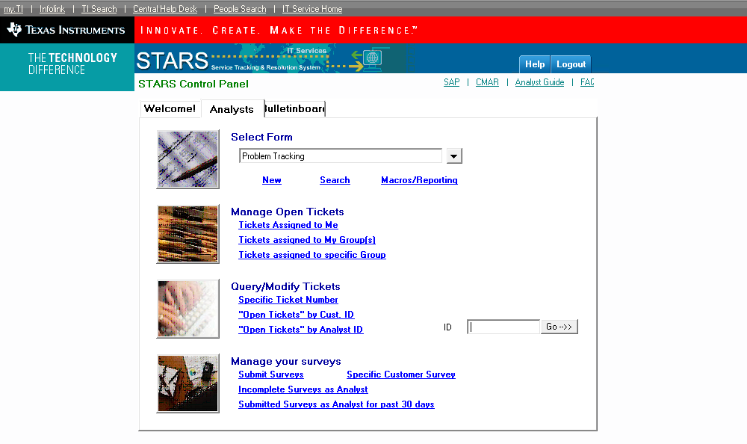

CMAR

Web

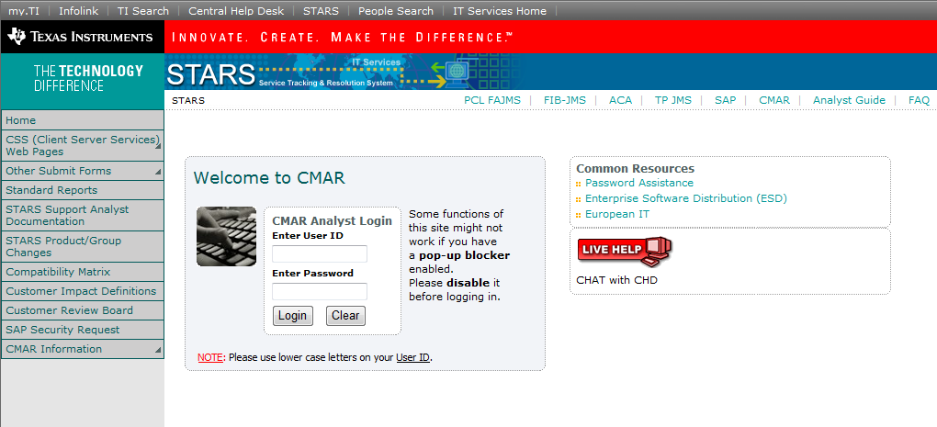

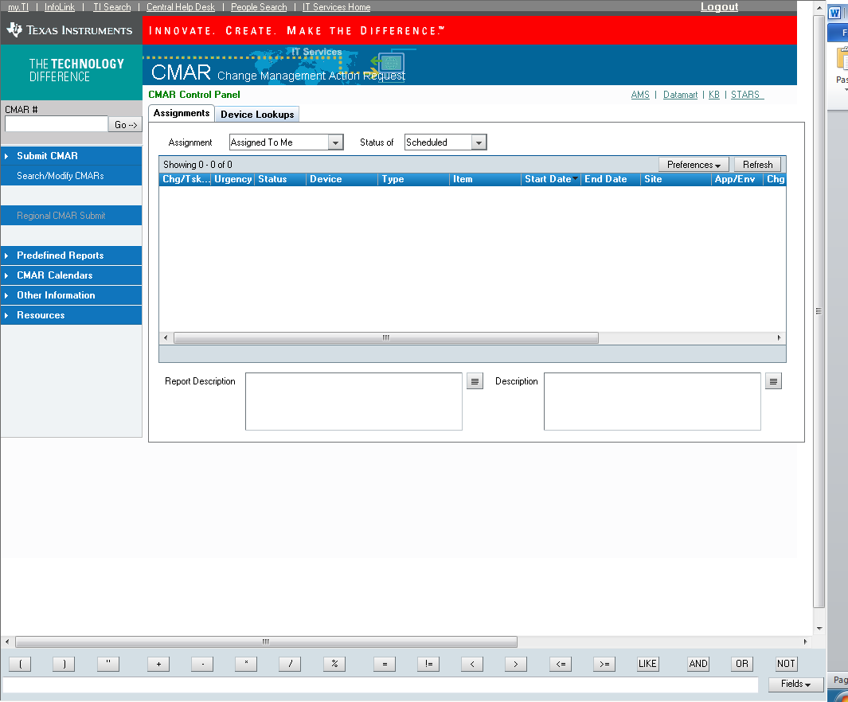

Client
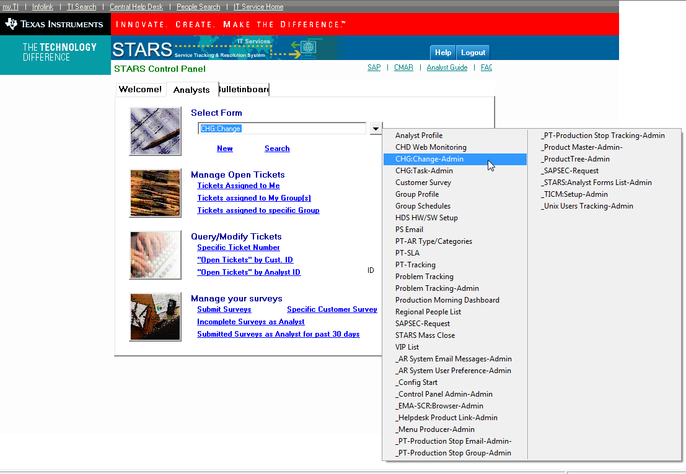
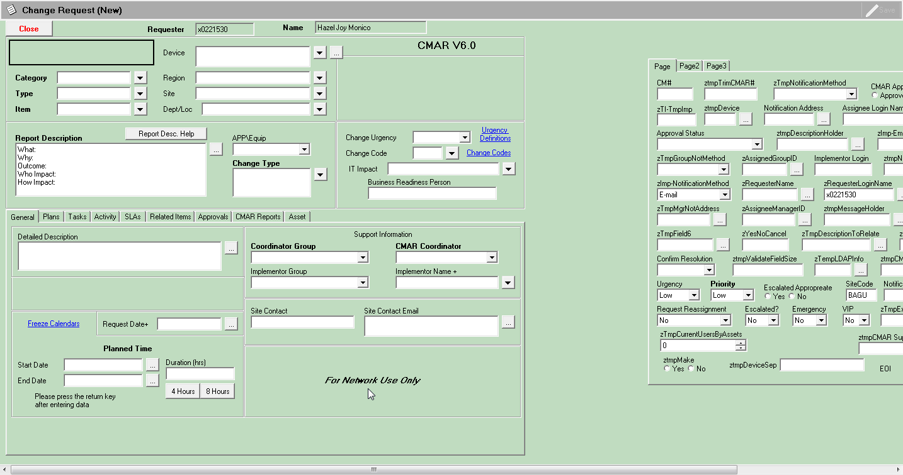

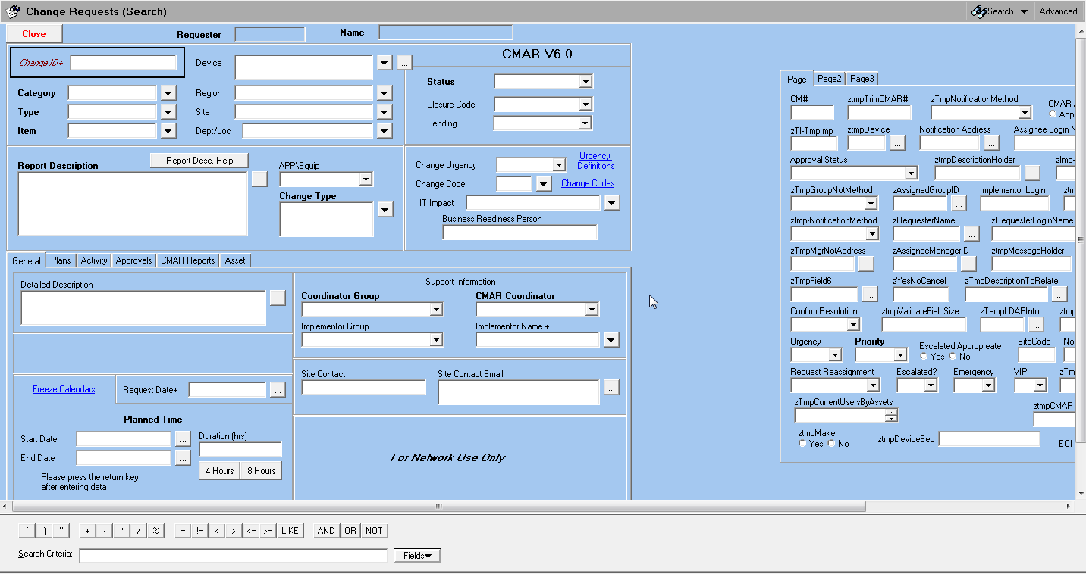

AMS

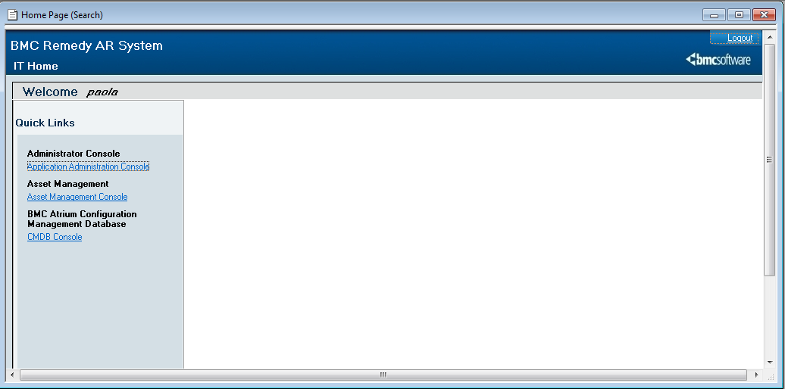
AMS Homepage

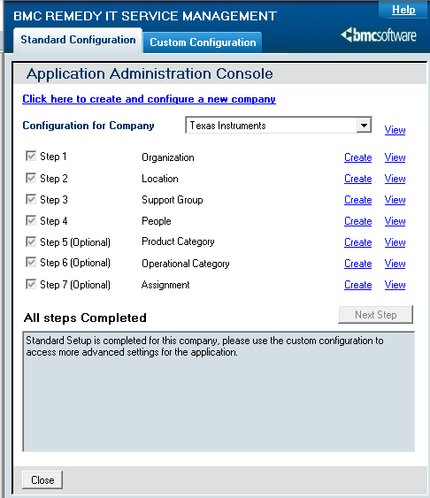
Application Administrative Console

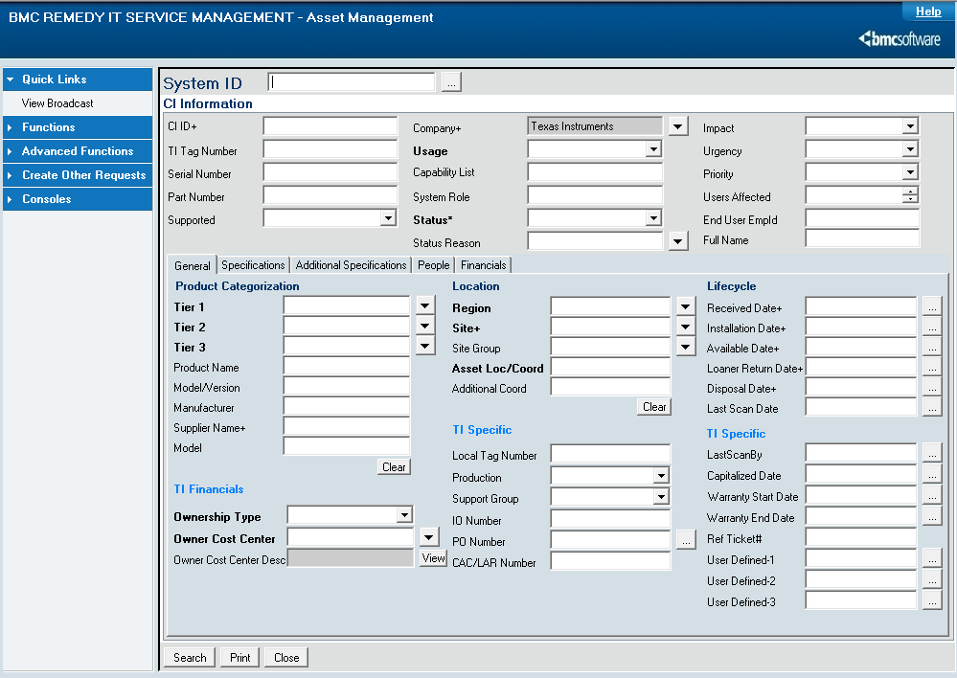
Computer System Form

Server Config
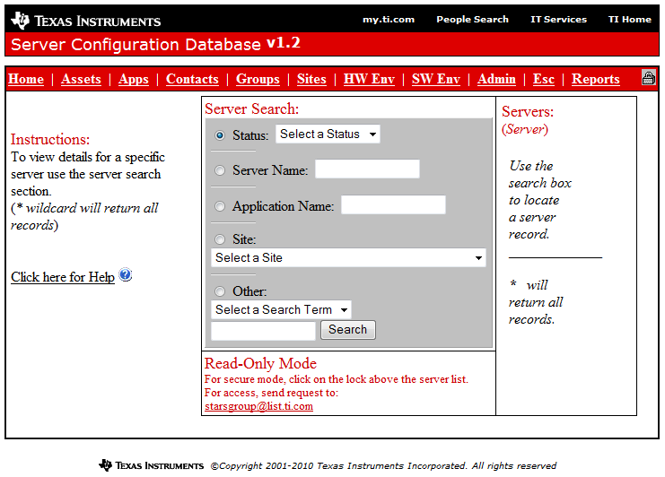
This is the Server Configuration Homepage.

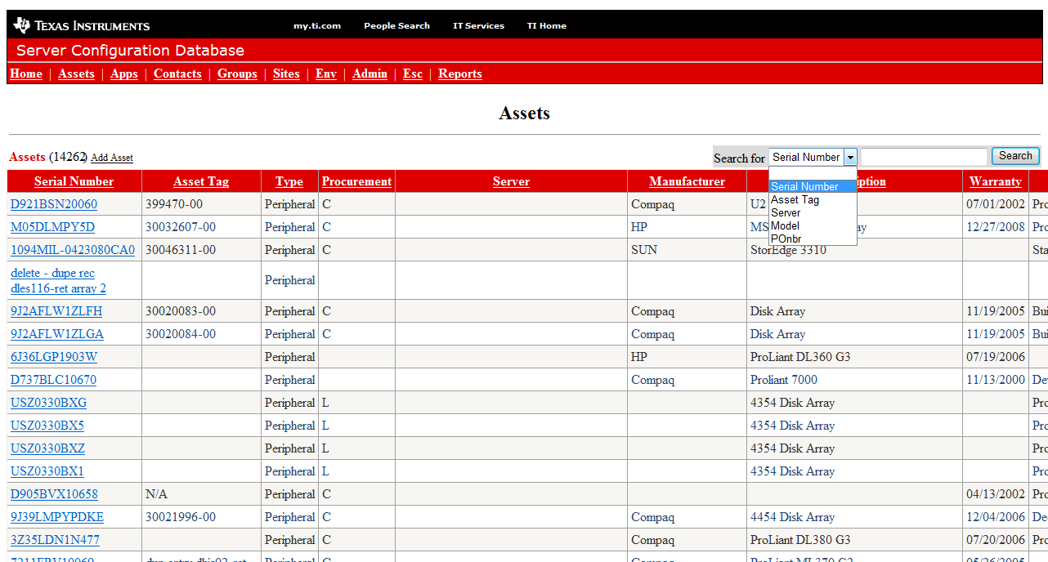

To Search for by Serial Number, you click on the "Assets" link in the menu bar and choose Serial Number under the Search dropdown list.

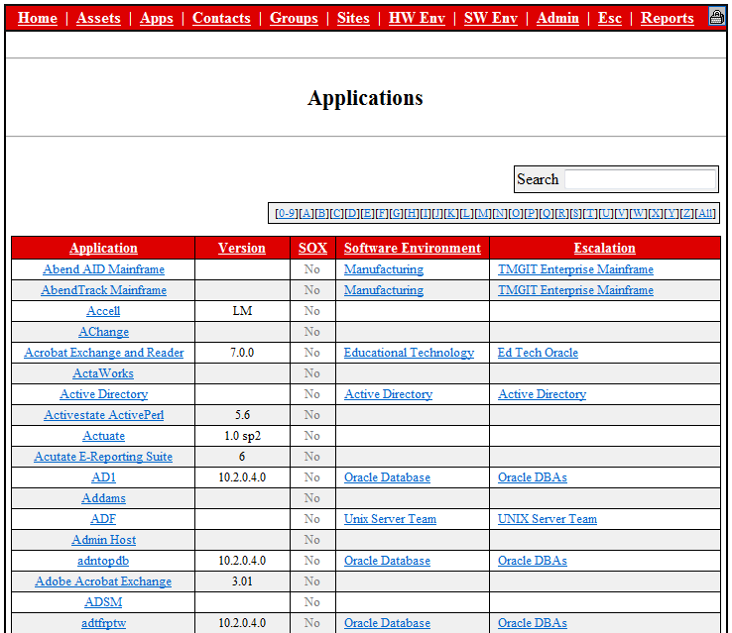
This is the Application page. This is where you can look at specific applications and its details.

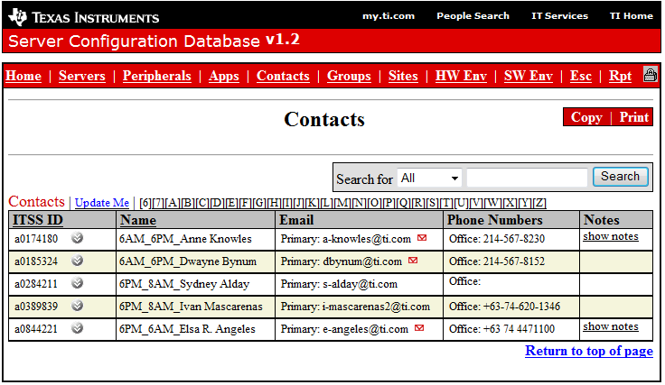
This is the Contacts page.

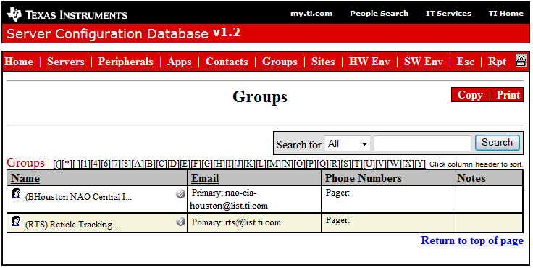
This is the Groups page.

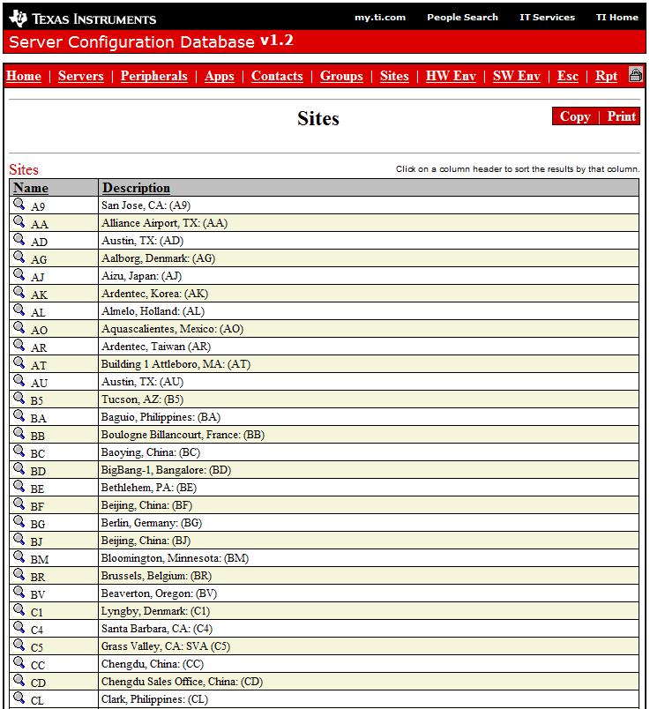
This is the Sites page. This is where you will know what and where your server is located.

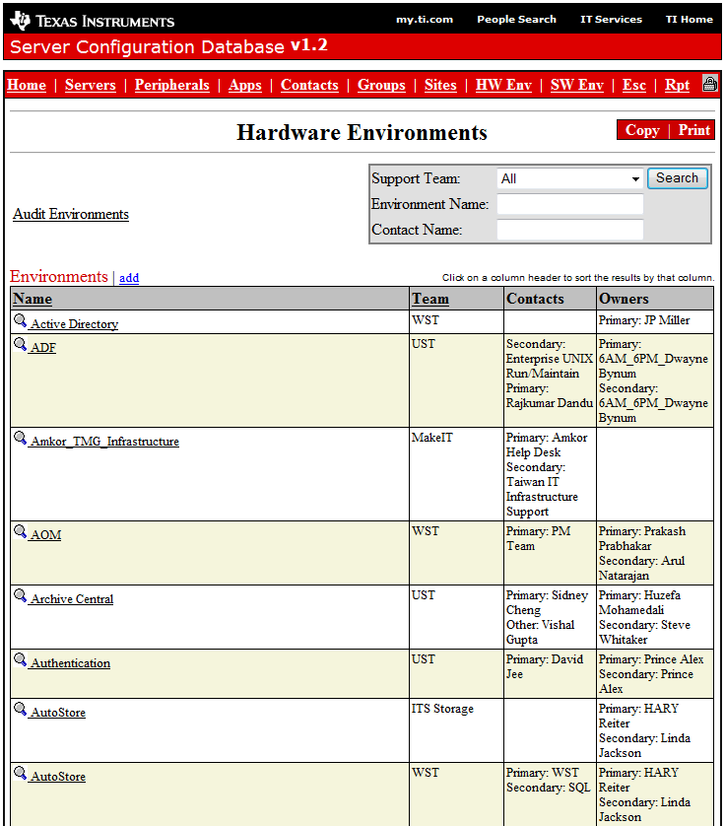
This is the Hardware Environment page.

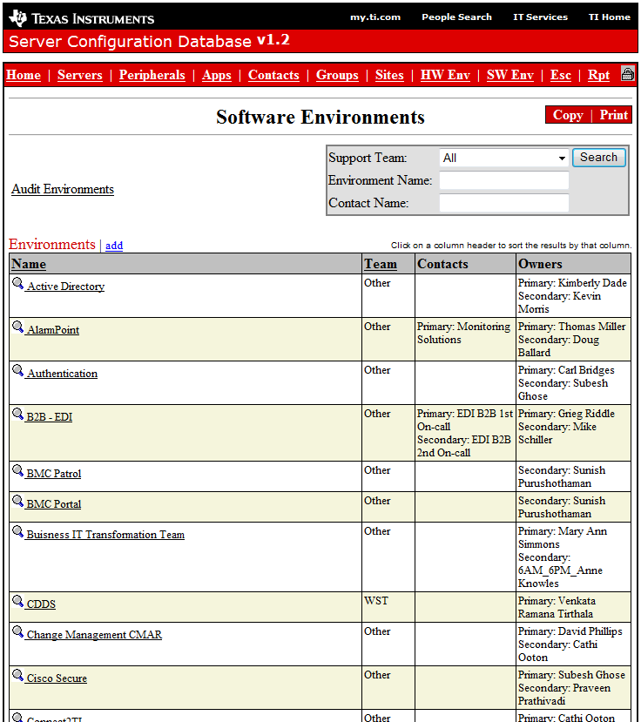
This is the Software Environment page.

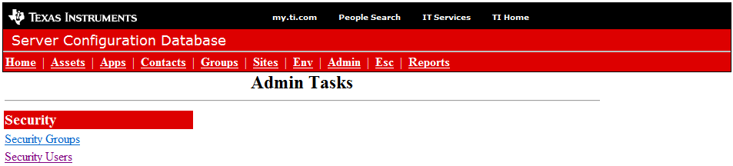
This is the Admin page.

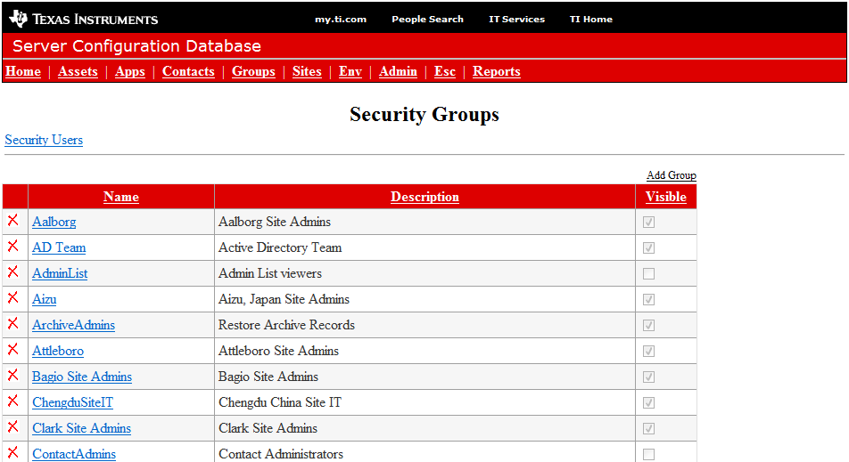

This is the Security Groups page under the Admin page. This is where you can add/remove security group/s.

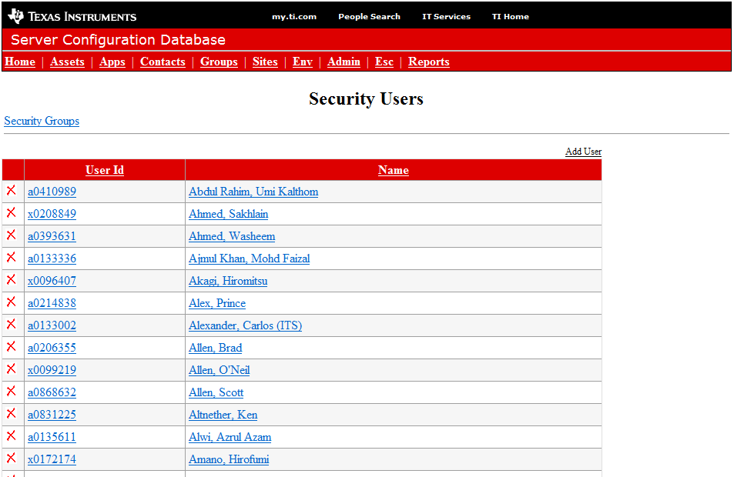
This is the Security Users page under the Admin page. This is where you can add/remove security user/s.

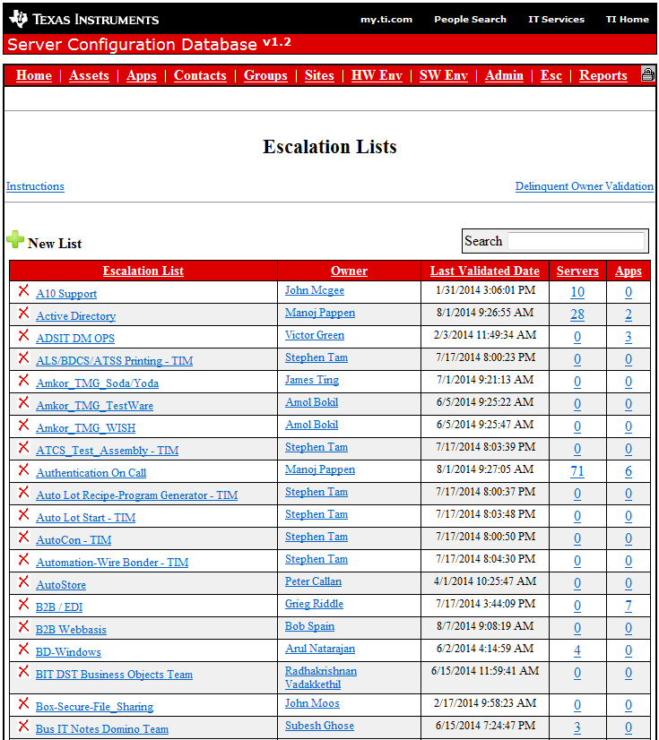
This is the Escalation page.

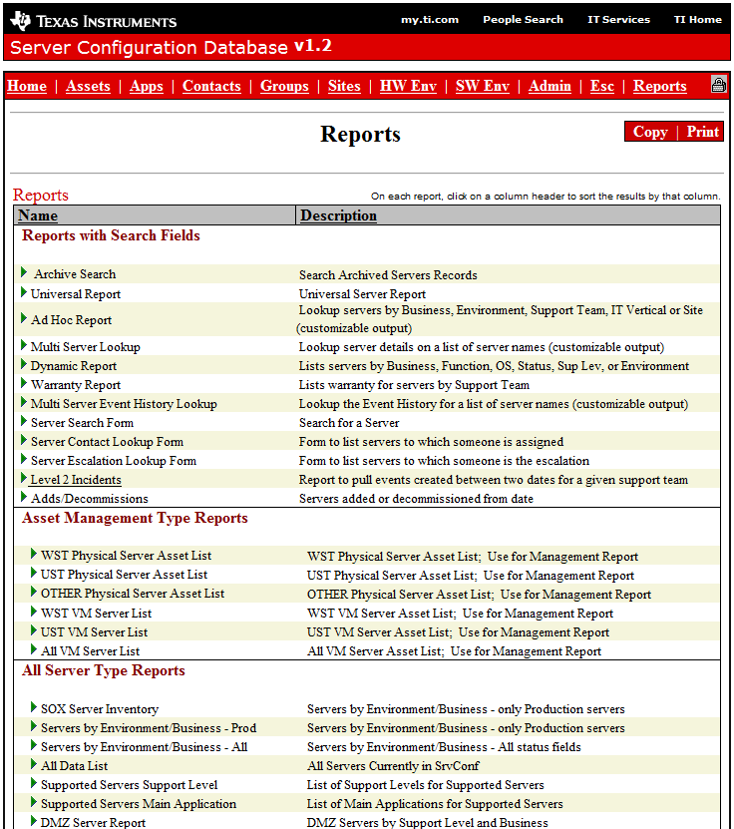
This is the Reports page. This is where you can find all kinds of reports pertaining to servers.

KB
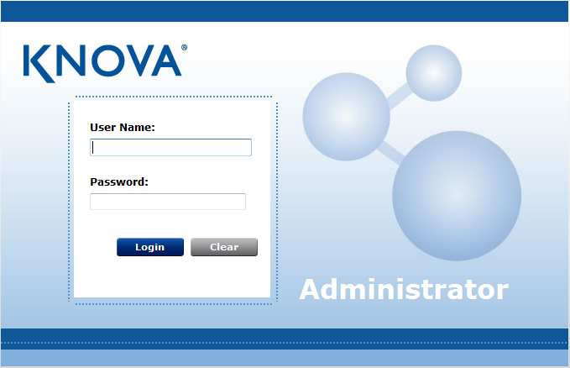
Administrator account

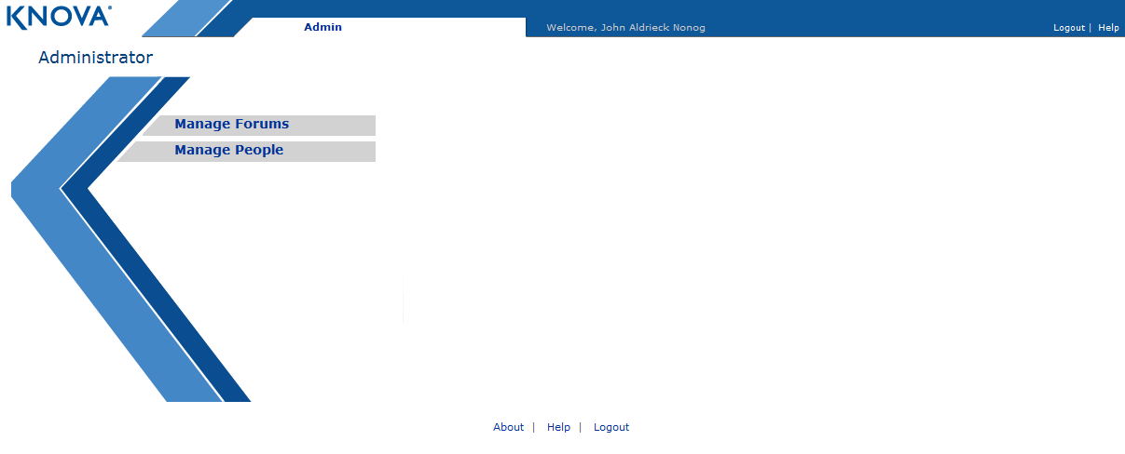
Inside Role Administrator account, show only role modification functions for KB Users

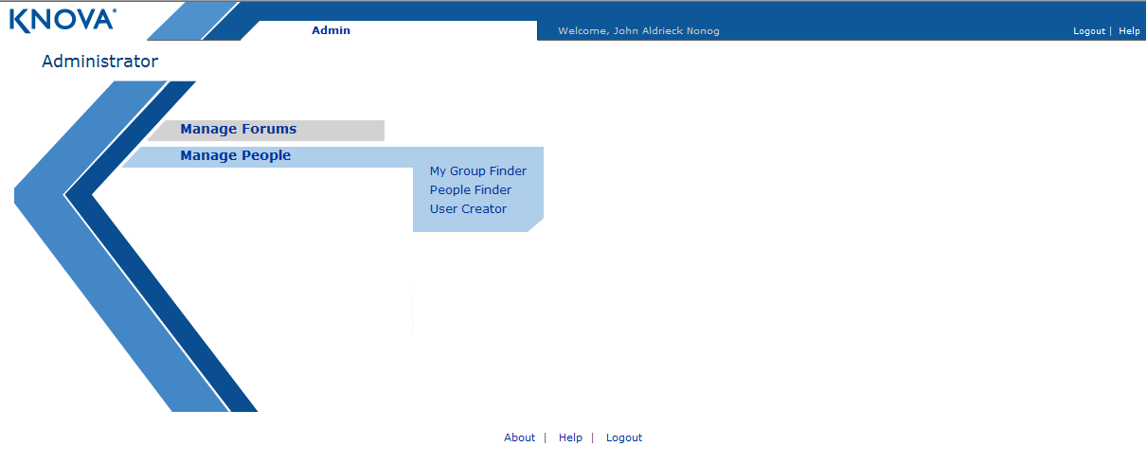
Role Administrator work around, find, modify and create user

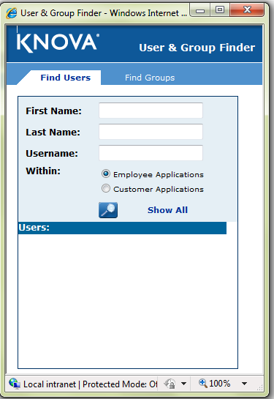
Finding users in KB

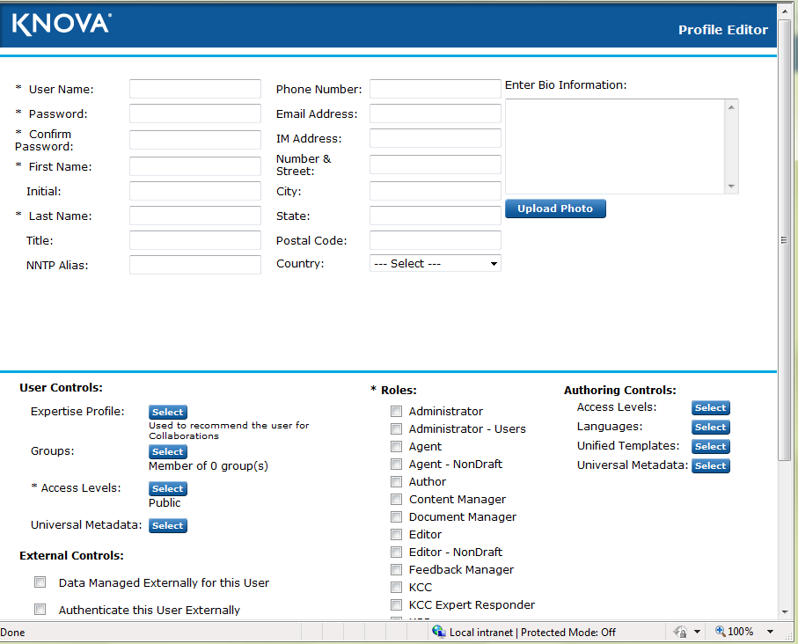

Show the from for creating/modifying KB profile account
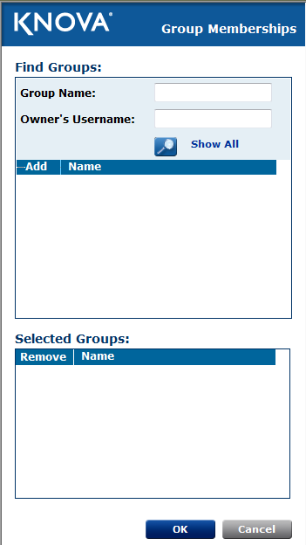
Configuring group inside KB profile account

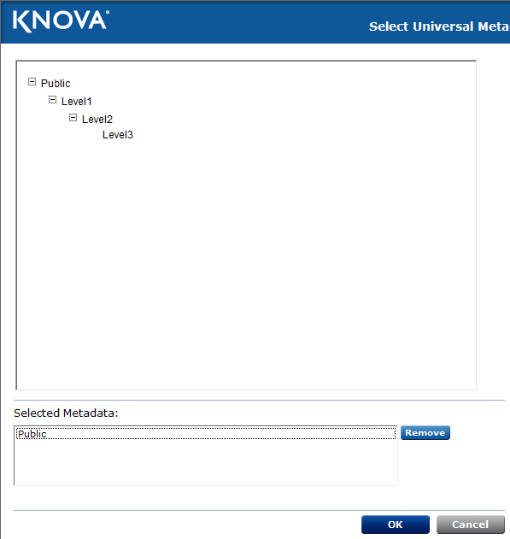
Configuring document access level for KB profile account

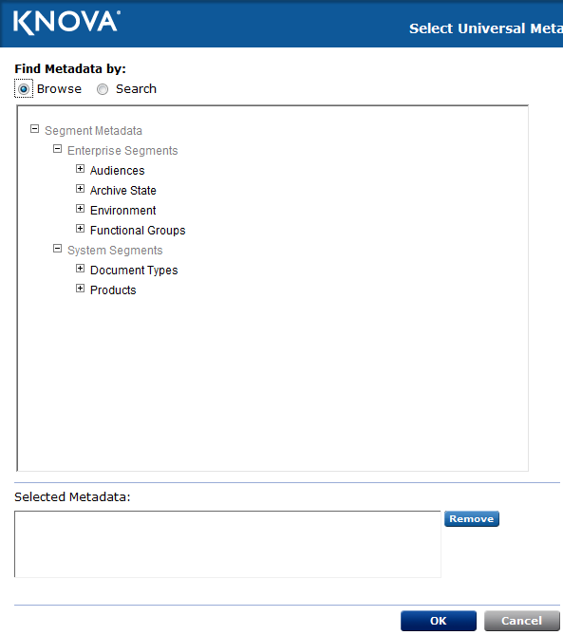
Setting up Metadata or microsite that the KB analyst may have

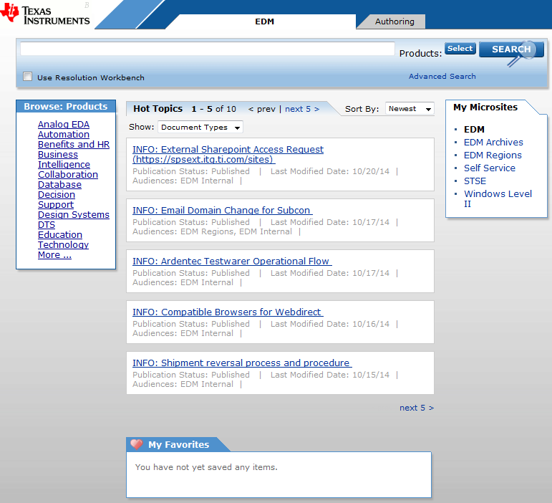
Inside KB Contact Center

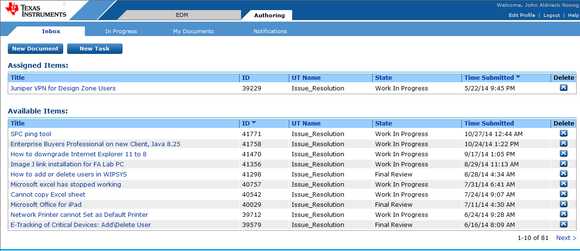
Shows the documents for upload

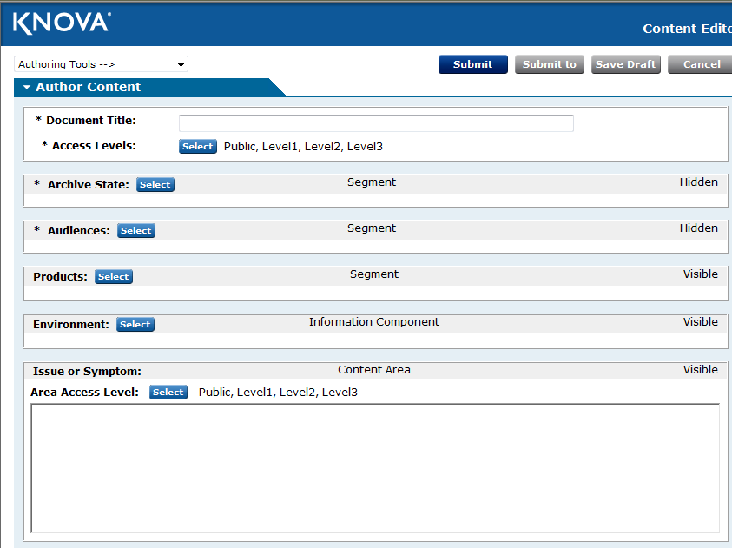
Shows from in creating document in KB

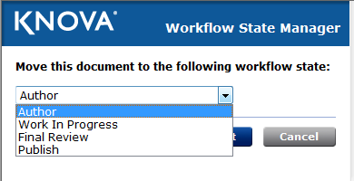
Show a document can be published either on the 4 items listed as seen on the image

Application Design

Relation to External Systems
Relationship of the application to the external systems/applications should be specified in terms of inputs/outputs. Pictorial representation may be used for clarity.

Not Applicable

System / Sub-system Architecture
The overall system and sub-system architecture should be specified pictorially. The decomposition of the application into modules (or functions) and brief description of modules should be stated.

Inter-module Relationships
Interfaces, dependencies & relationships among modules should be explained. Data Flow Diagrams may be used here.
STARS
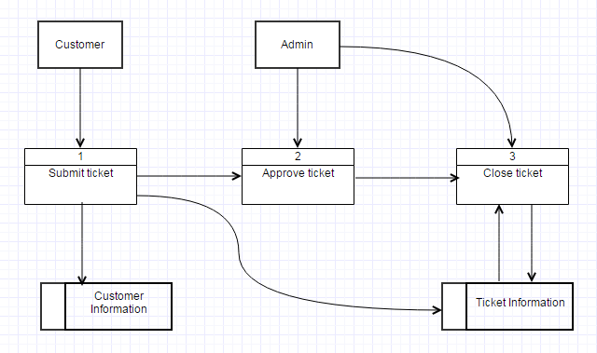
CMAR
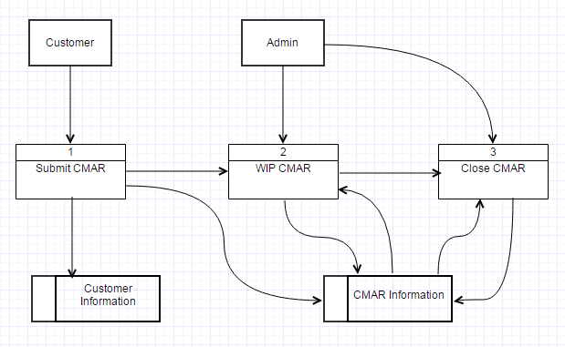

AMS
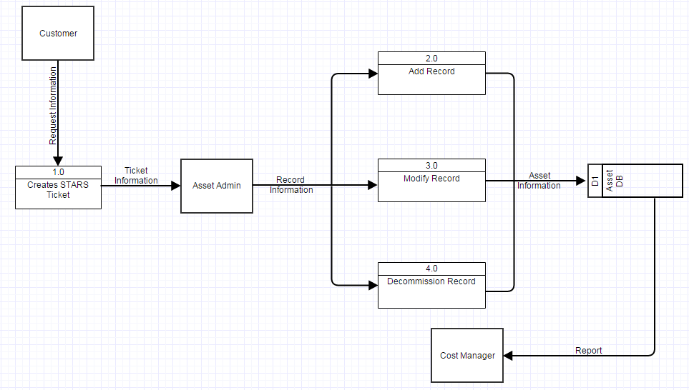
SrvConf
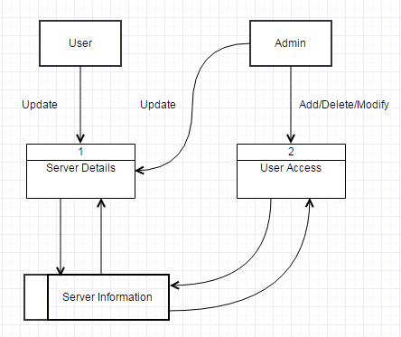
KB
Knowledge Base (KB) is a user dependent application which needs records of user, microsite, groups, products setups and documents. Once the user create a document in KB, the application logs the user name, microsite, groups product and additionally the date from the document is created. Below image shows the data flow of the application. Dashed box are the output of the application
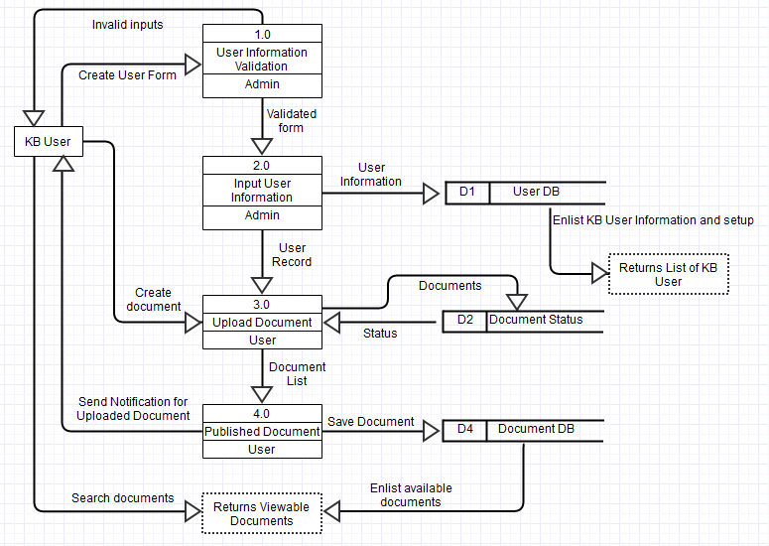

Application Modules
Refer to the User Interface Section (Section 8)

Module Name and Description

Design Details

Global Data Structure References

Module Specific Data Structures

Database Details

STARS
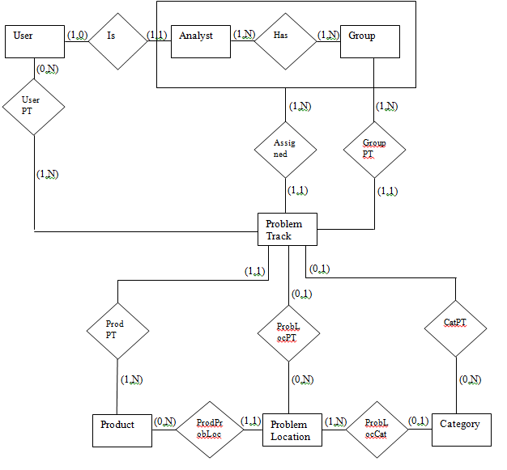

AMS
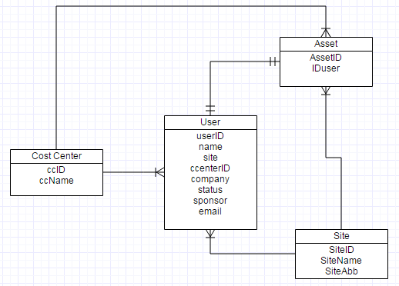

KB
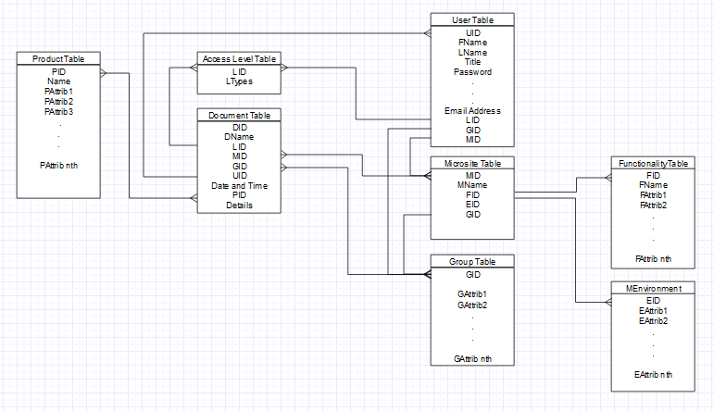

SrvConf
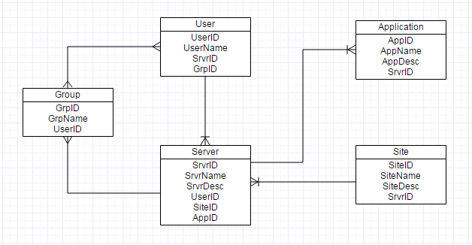

Batch Job Details

Daily Batch jobs
LDAP (Lightweight Directory Access Protocol)Job
Runs 9 am and 10 pm Dallas time

Feeds user information to AMS from Directory Services (active vs inactive users)

https://itsps.itg.ti.com/sites/EMAGroup/Shared Documents/STARS Team Apprenticeship_OJT/Magel AMS Docs/How to rerun the LDAP Job_V2.doc

PCU (Personal Computer Update) Jobs
Runs 7 am and 8 am Dallas Time

Feeds Hardware details to AMS mostly used by Desktop services team

https://itsps.itg.ti.com/sites/EMAGroup/AMS/Shared%20Documents/Forms/AllItems.aspx?RootFolder=%2fsites%2fEMAGroup%2fAMS%2fShared%20Documents%2fAMS%20Documentation%2fPCU&FolderCTID=&View=%7b93B6FDA0%2dF008%2d443A%2d8DE7%2dBEB9ED613301%7d

ZeroByte Job
Runs 3am Dallas time

Checks whether there is a zero byte file in the UNIX box, particularly with regards to TI Work schedule and Holiday schedules. This prevents miscomputation of group SLA.

https://itsps.itg.ti.com/sites/EMAGroup/STARS/Shared Documents/STARS Documentation/Release Documentation/2013 Releases and Processes/[STARS Release v7.3]_Bug Fixes -- SLA and Zero Byte issue/Design Document/Zerobyte.docx

Weekly Batch jobs
Not applicable

Monthly Batch jobs
Not applicable

Quarterly Batch jobs
Not applicable

Global Data Structures and Shared Data Functions

LDAP
STARS, AMS and CMAR are all dependent on this application to get employee information.

Critical Functions
Not Applicable. Enhancements are being done by the Level 3 support.

Testing Strategies
AD HOC Testing
- Prepare a checklist to be approved by TI counterparts
- Once approved proceed to the test environment
- Do testing
- Proceed to getting a user acceptance test from customer

Test Data

Not applicable

SLAs & Service Patch Deployment

Configuration Management
The BMC Remedy Admin tool contains configurations of forms, active links, filters and other jobs that are being used by STARS and AMS.

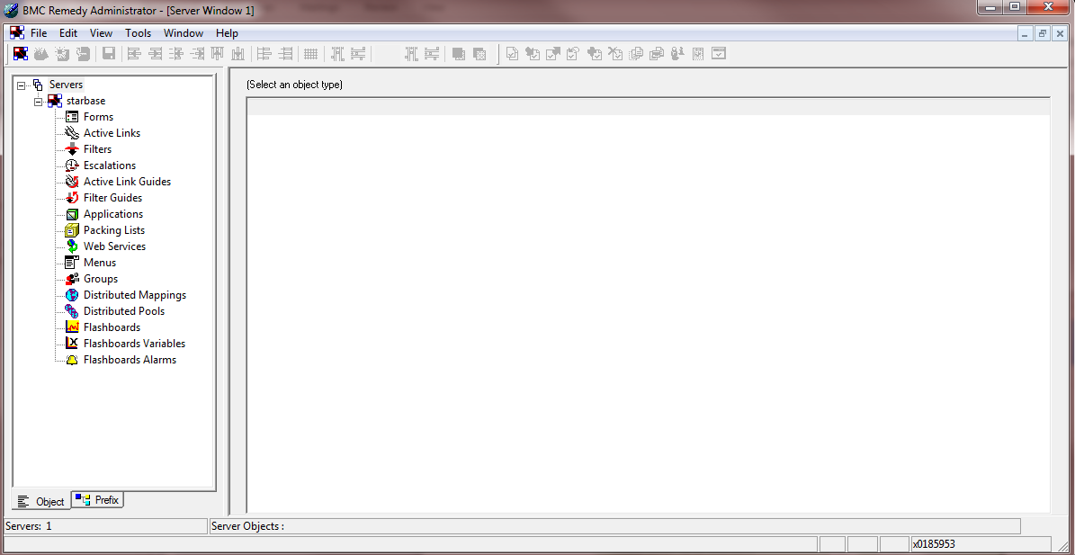

Service Level Agreements (SLAs)
(This lists the application owners, SLAs, when does the system have to be up (application availability requirement), batches processed, how tight is the window now etc)

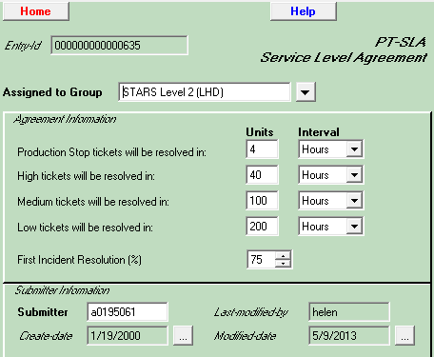

Maintenance and Service Patch Deployment Process

Maintenance and Service Patch Deployment processes are being done by the Level 3 support

Emergency fix Management

During emergency fixes issues are being escalated to the Level 3 support.(Tiers and Tech Leads of Tiers). Below is the escalation matrix being used by the team.
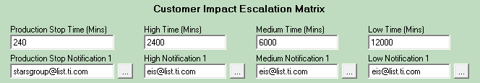

TI Track Lead: Mark Villamar

Level 2 Support:
Hazel Monico
Jeffery Balingan
Joenard Mamanteo

Level 3 Support:
Jojo Ochavillo
Janssen Nunag

Reusable components

Limitations

STARS
STARS have a limitation in adding help desk, products, admin access

Business continuity & Disaster recovery plan
(This section outlines information on the 'vital records’ (documents needed for the continuation of operations in the event of an outage to the application) produced or needed by the application)

Disaster Recovery Process
(This sub-section outlines the disaster recovery process currently followed for application. The Disaster recovery solutions followed and the recovery strategies used)

Vital Records
(This sub-section lists all the vital records produced and needed by the application)

References

BCP development toolkit

References
Refer to the Documents section

Application History

Typical Problems
RPC Bind error
-caused by insufficient data connection

Empty Initial Notification
-the ticket submitted does not have an auto assigned group

ARsystem Error
-wrong ticket information

Release History
Not applicable for Level 2 support

17. Learning

